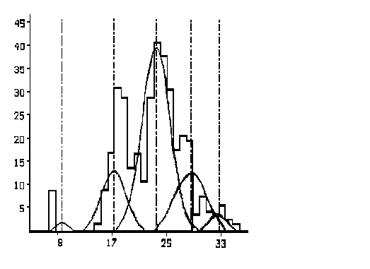The “Dublin Bay Prawn”, Nephrops norvegicus (also known as the Norway Lobster) is a very valuable commercial species in the Irish fishery. Its distribution ranges from Iceland to Morocco and into the Mediterranean as far as Egypt. The Irish Nephrops fishing grounds include the northwestern Irish Sea, certain areas in the Celtic Sea and off the west coast of Ireland on the Porcupine Bank. Irish landings of Nephrops norvegicus alone amount to approx. £13.5 million per annum, making Nephrops one of the most commercially valuable species in these waters.
Length Frequency (numbers)
Carapace Length (mm)

Due to the economic importance of this species, and the amount of fishing pressure to which it is subjected, it is vital that regular stock assessments are carried out to ensure that a viable Nephrops resource can be maintained. One method of assessing the
status of a population is to monitor its age structure. This can tell you a great deal about the population, e.g. generally a population in which there are many old individuals indicates relatively low fishing pressure. The opposite is true for a population that consists of mainly young and immature individuals; such a situation would suggest a reduction in the numbers of spawning stock within the population, which may be due to overfishing.
Yr. 0
Yr. 1
Yr. 2
Yr. 3
Yr. 4

Figure 1: Example of Nephrops norvegicus length frequency distribution, which has been analysed using MULTIFAN. Note positioning of modes/peaks and their corresponding ages.

In view of the importance of the Nephrops norvegicus fishery, the Marine Institute, Dublin has been monitoring this species over the past number of years. One of the projects currently underway at the Institute is dedicated to measuring the age of the various Nephrops populations around the Irish coast. This project is funded by the EU and also includes project partners from the Dept. of Agriculture, N. Ireland; IEO, Spain and IFREMER, France.

Unlike fish and molluscs, the Nephrops moults every year and has no permanent hard body parts which carry with them a record of growth. However, length frequency distributions of Nephrops norvegicus display a series of modes or peaks, each of which represents a year class. A computer programme called MULTIFAN is used to analyse this data; the programme statistically examines each mode and assigns biologically correct ages to the data. It provides us with mean length at age and information on growth rates. Several years can be analysed at any one time and in this way we can follow the growth of a particular group of individuals through the years. Results from the western Irish Sea to date show that Nephrops attain a carapace length of 17mm following their first year, 22mm after 2 years, 27mm after 3 years and 32mm after 4 years. Older individuals are very difficult to age due to the significant slowing down of their growth. The ages given above are approximate and vary according to location. Using this programme has meant that we can now monitor more closely the

growth patterns of the Nephrops population. Changes in growth rate over a number of years can be observed, as can differences in growth characteristics due to type of habitat.

MULTIFAN is a valuable tool in Nephrops research, which will hopefully allow us, at the Marine Institute, to continue to support the successful management of this important Irish fishery by the Department of the Marine and Natural Resources.

Nephrops norvegicus

Information Leaflet
Nephrops norvegicus

Further information:

Similar information leaflets are available from the Marine Institute which cover the following topics :
- What is Fisheries Research?
- Ageing of Fish
- Research Surveys
- Discarding
- The Fisheries Assessment Technician Programme
Ageing of
the Dublin Bay Prawn

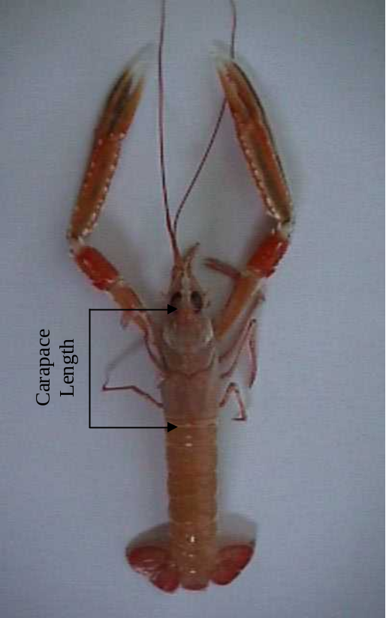For more information contact:

Jennifer Whitmore @ 01-8228239 .

Or contact the Marine Fisheries Services Division, Marine Institute, Abbotstown, Dublin 15.



Marine Fisheries Services Division,
Marine Institute,
Abbotstown, Dublin 15. Eire.
Tel.: 353 . 1 . 8228200
Fax.: 353 . 1 . 8205078
Email : marine@marine.ie
Web: www.marine.ie

